1NT19IS152
Shwetha
C1 batch
24-05-2020

1.Create a directory named by your name

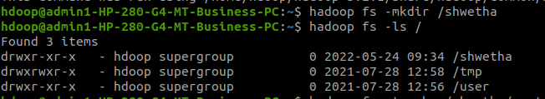

2. Add two empty files into it

3. List all the files in the directory that you have created

4 Create one more directory by your usn and put that inside the directory of your name
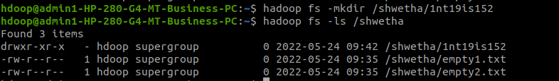

5. Create a file in your local system by the name_usn.txt and add the contents as
"Syntax to list Is command is hadoop fs -Is "
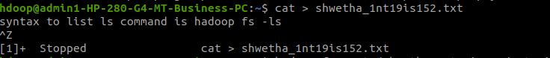

►Put the file usn_name.txt in your hdfs directory called usn

Put empty file of hdfs into the local file system

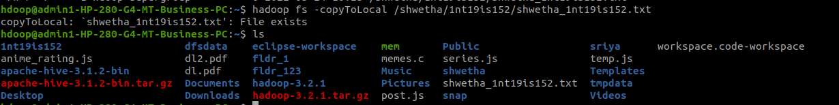

Experiment with cp command:
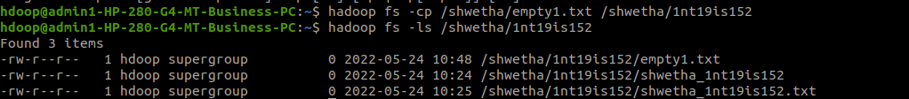

►Use my command to move files from local file system and hdfs file system
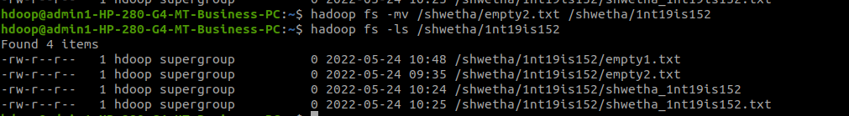

► Display the total size of all the files in name directory
